User Story ID <789>

**Use Case Diagram**

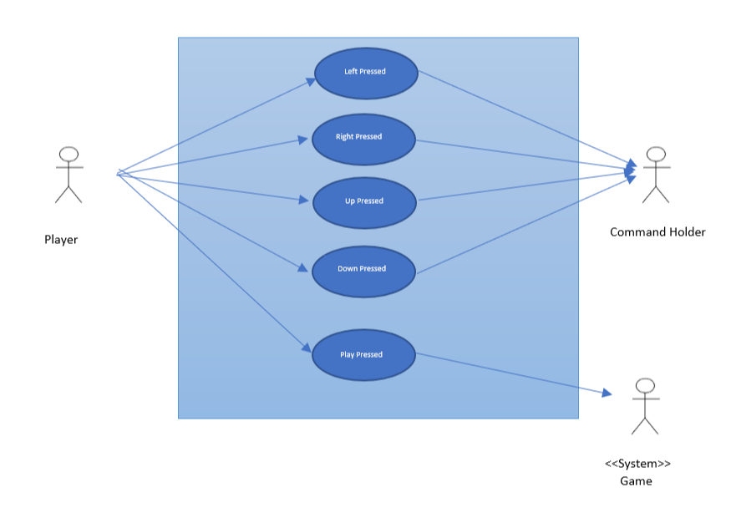

**Sequence Diagram**

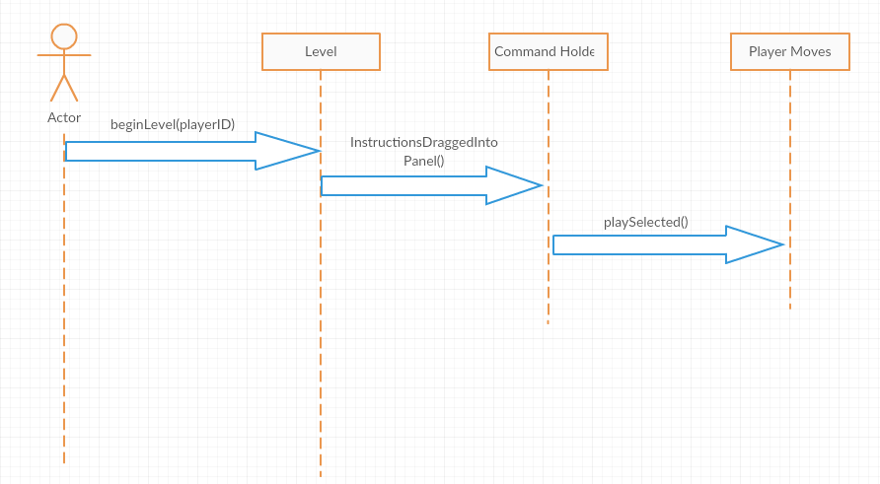

**Class Diagram**

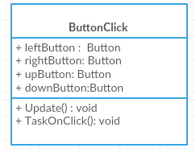

User Story ID <791>

**Use Case Diagram**

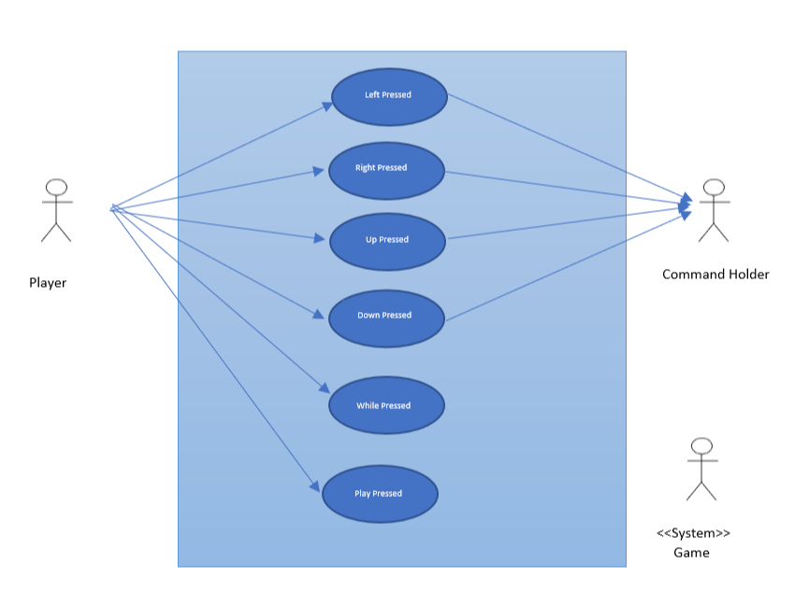

**Sequence Diagram**



**Class Diagram**

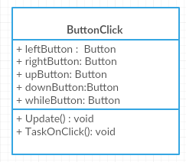

User Story ID <799>

**Use Case Diagram**

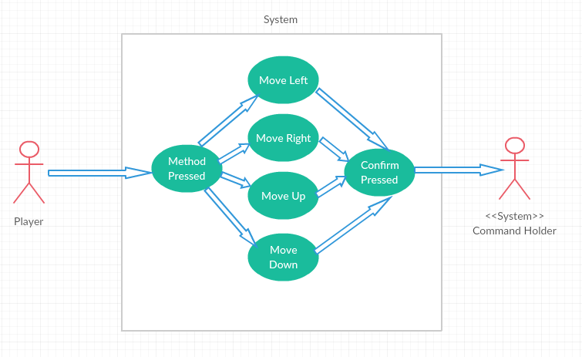

**Sequence Diagram**

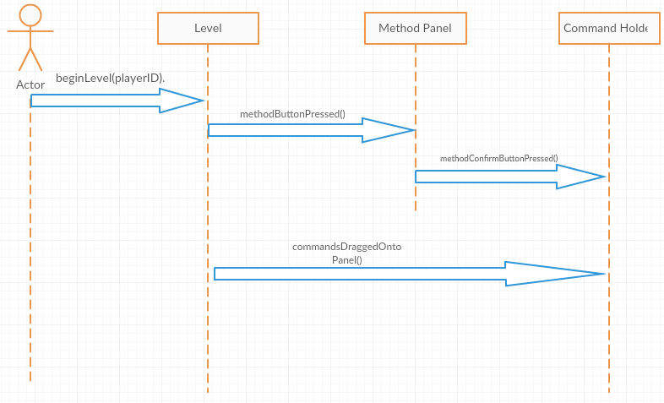

**Class Diagram**

